Opening Your Web Page

- Open your page using your Internet browser. Your address is “http://xx###.k12.sd.us”, with “xx###” being your state user name (the same one you use to log in to the state e-mail). Example: http://lt012.k12.sd.us

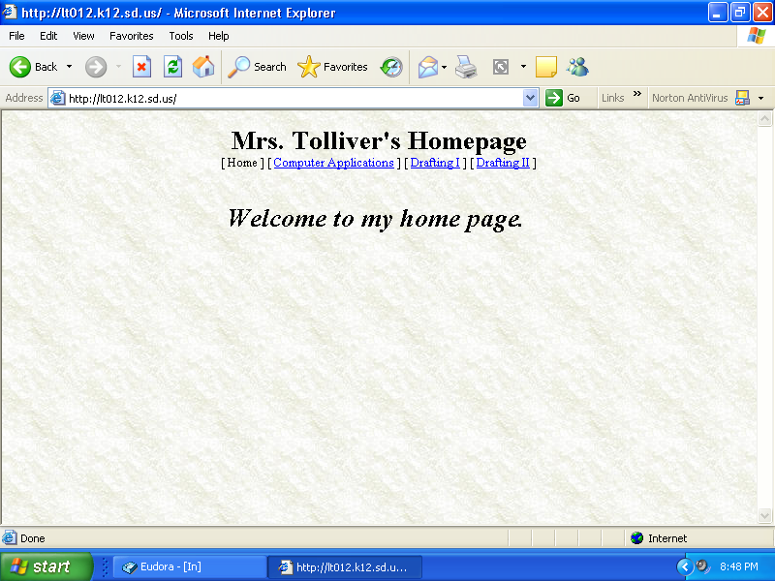

Opening Your Web Page in FrontPage

- Once you have your web page open in your browser, click on the “Edit in FrontPage” button.

- FrontPage should open with a log in dialog box. Use your state user name and password (both are the same that you use for your e-mail). DO NOT CHECK “REMEMBER MY PASSWORD”. Click “OK”.

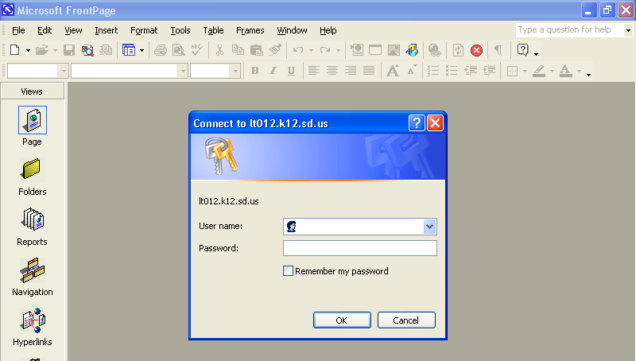

- Your default.htm page open up in FrontPage. If you do not see the folder list on the left side, you can open it by clicking on the toggle button, or by clicking on “View” and clicking on “Folders list”.
Toggle button

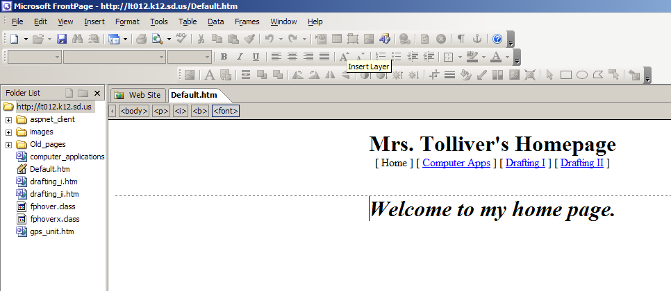

- The default page is the page that opens first from the Internet. You do not want to change the name of this page. You can change the title of this page, using folders view or navigation view, which would change the banner across the top of the page. However, you shouldn’t change the name “default.htm”. To change views, click on the “Web Site” tab at the top, and choose the view at the bottom. 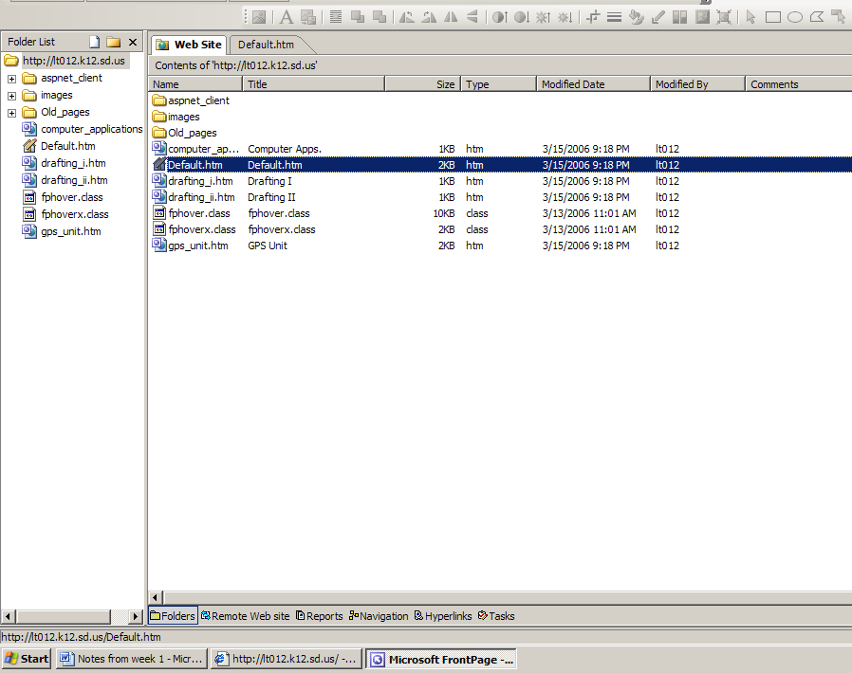
Web site tab
Views

Editing your Web Site

- Click on “default.htm” to open your default page. Now you can edit it by adding borders, banners, pictures, backgrounds, themes, text, etc. Add pages to your web site in navigation view.

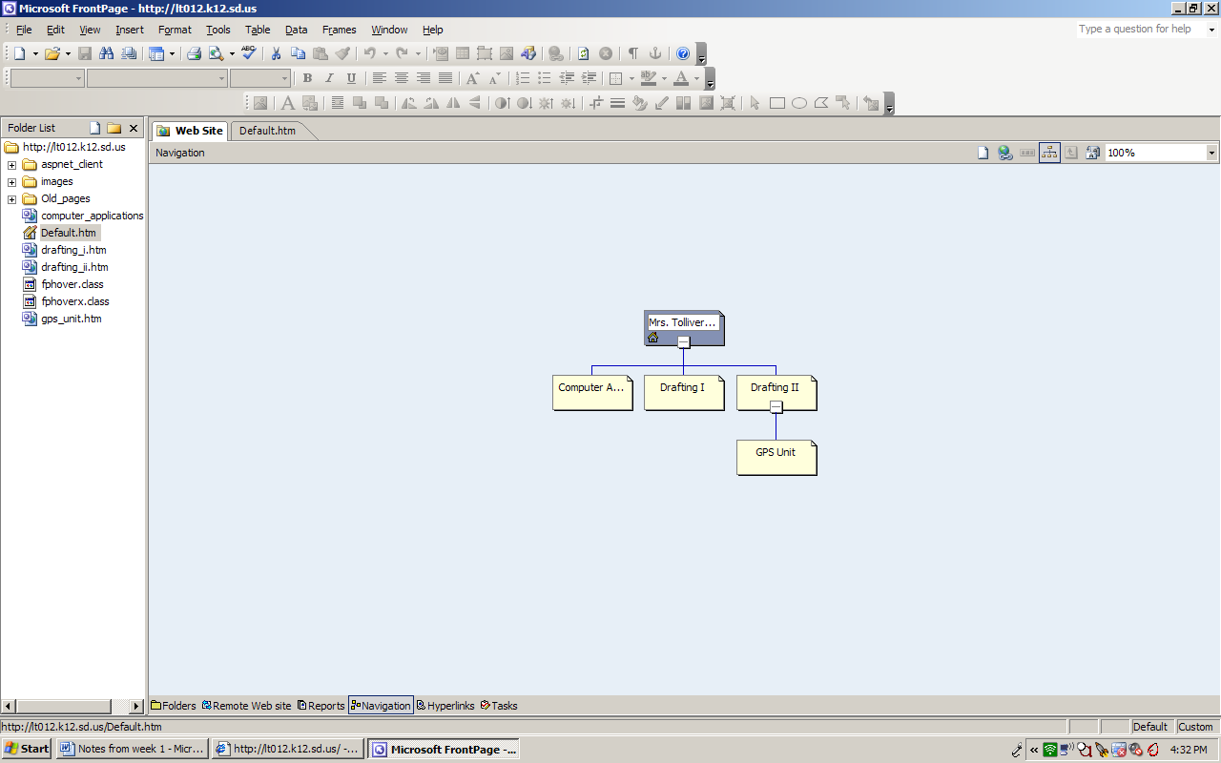
New page button

Shared Borders
- Shared borders add permanent space to a specific part of your page. For example, you can choose to add a shared border to the top of your page, displaying a page banner and a link bar.
- Shared borders display the same content on each page in your web site.
- This is a sample of shared borders across the top and along the left side of a web page.

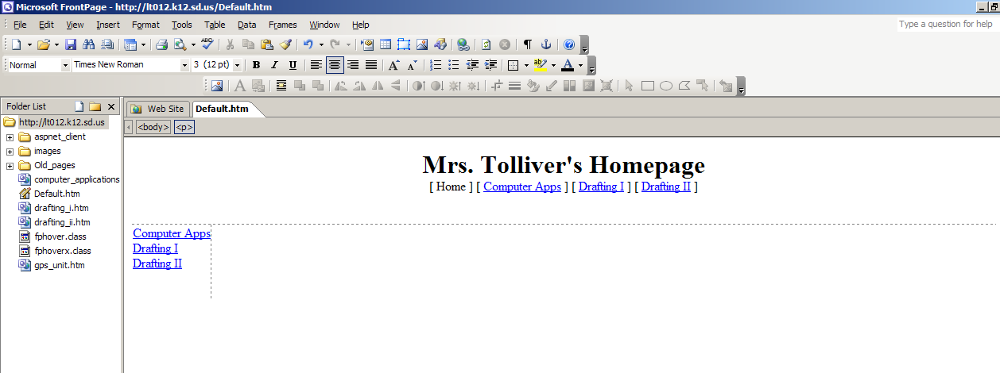
Shared border on the left side
Shared border across the top

Themes
- A theme is a coordinated collection of graphics, colors, and fonts applied to individual pages or all pages in a web site. To add a theme to your pages, click on “Format”, and click on “Theme”. The Themes pane opens on the right side of your screen. To choose a theme, click on the theme of your choice. To apply it to all pages, hover over the theme, click the arrow, and choose “apply as default theme”.

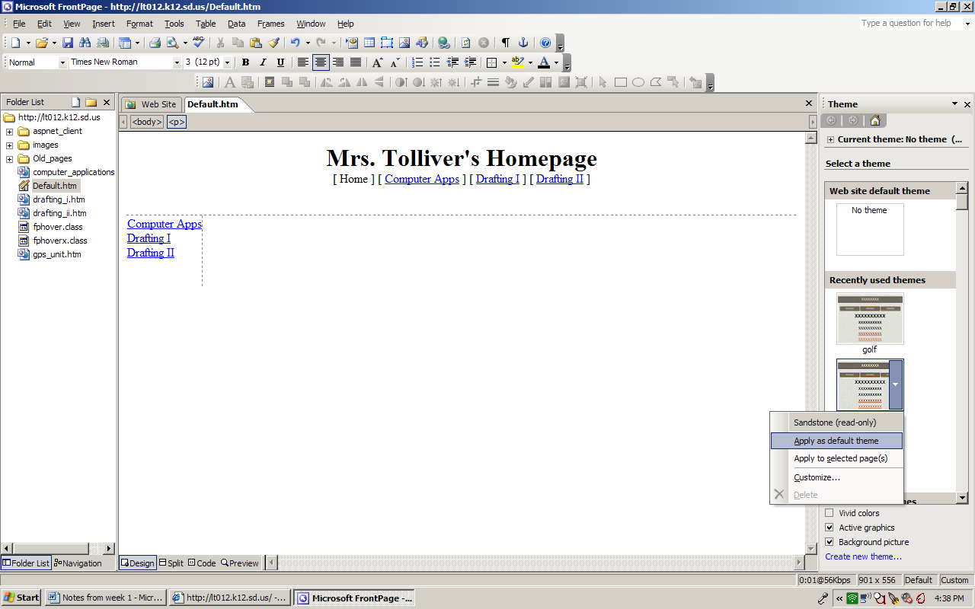

- You can also change the color scheme, font, background, etc. of your theme by hovering over the theme on the right side of your screen, click the arrow beside the theme, and click on “customize”.

Background
- To add a background color without having a theme applied to your page, click on Format, and click on “background”. You can choose to apply a color for your background, or you can browse to use a picture for your background.

Closing and Saving Your Web Page
- Each page you close in your web site needs to be saved. The computer will ask you to save if you don’t save before closing. You can determine which pages need to still be saved by seeing an asterisk next to the page name on the tab at the top.

