Inserting Tables

Adding tables to your webpage can help to balance your text and images uniformly on your page when opened in any browser.

- Click on “Table”, “Insert”, “Table”. The table Insert Table dialog box opens up. You need to decide how many columns and how many rows you want.
- If you do not want borders to show on your web page, change the cell padding and cell spacing to “0”. I also suggest changing the borders to “0” and checking the “collapse borders” box.
- Click OK.

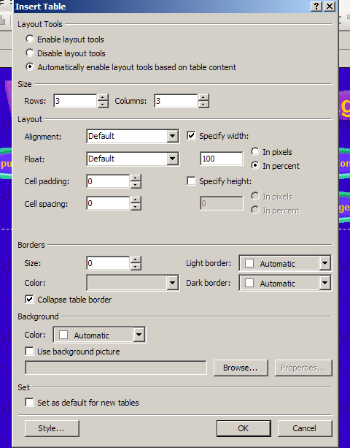

- Type text in cells. To merge cells, select the cells you want to merge, and click on “Table”, “Merge Cells”. This combines cells into one cell. An example would be if you want a title centered above the rest of the table. You would merge the first row of cells and center the title’s text in that top cell.
- To change column width, click on the column border and drag the borders where you want them.

Inserting Images

- To insert images/pictures into your web page you need to first find the location of the images you want to use. It is easiest to save the images first on your H:/ drive.
- If you have images saved to your H:/ drive, a flash drive, or another location, click on “Insert”, “Pictures”, “From File”.
- Find the image and click “insert”.
- You may need to adjust the size of your image by using the corner handles.
- You can copy and paste images, but it is necessary to “embed” the image into your web page when you save and close the page. (If you try to save your page, FrontPage will prompt you to embed your images. Always say OK.)

Changing Backgrounds on Your Web Page

If you don’t want to use a theme on your web page, you may want to change the background color. You can use images, colors, or other backgrounds you find on the Internet.
- Click on “Format”, “Background”.

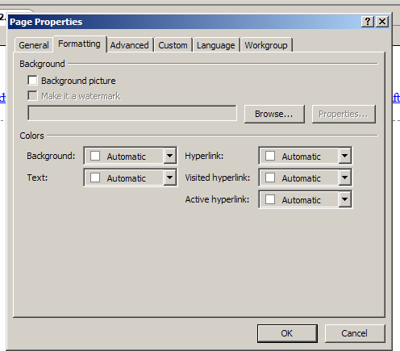

- From here, you can check the background picture box and browse for the picture you want for your background…OR
- Choose the background color from the drop list.
- Notice this is the same place you could change the color of your hyperlinks.

Importing Files

You can import Word documents, PowerPoint Presentations, and other files into your web site.
- Click on “File”, “Import”.
- Click on “Add file”. Find the file you want to import and click OK.

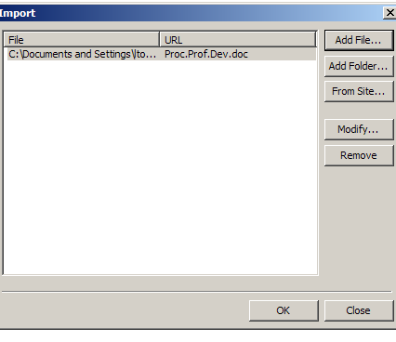
- Your file will appear in your folder list in FrontPage. You can just drag it over to your web page to add it.

Adding Hyperlinks

Hyperlinks allow the viewer to click on something (text or an image) on your web page and it will take them to another place within your web page or to another site.
- Highlight the text or image you wish to hyperlink.

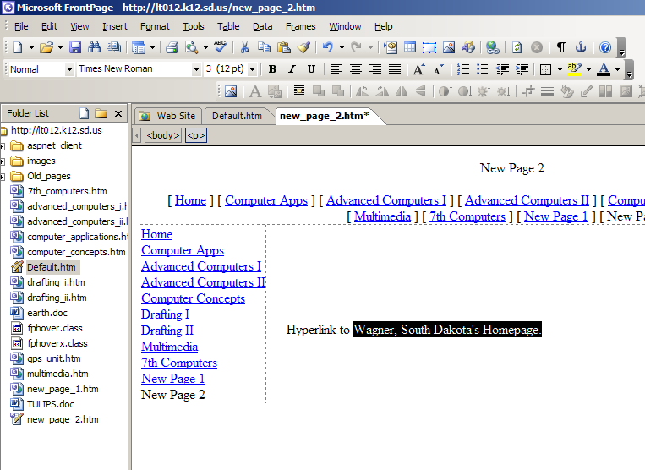
- Click on “Insert”, “Hyperlink”.
- Find the page you wish to link to, or type in the URL of the site you wish to link to.
- Click ok.

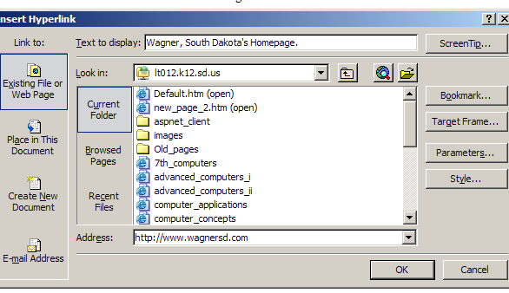

You can tell if text is hyperlinked by the default blue font and underline.

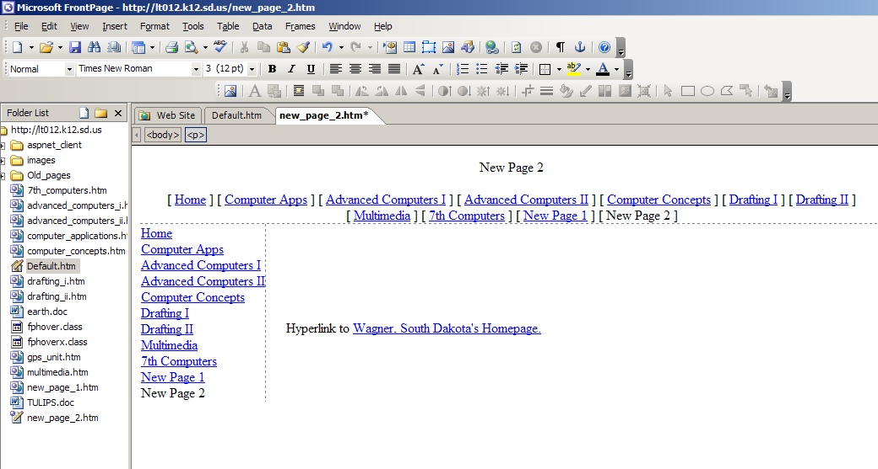

Adding Buttons

- Click on “Insert”, “Interactive Button”.

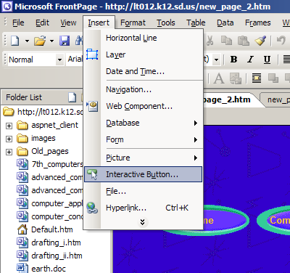

- Choose the button you’d like, and type the text you’d like to have show on the button.
- In the “Link” line, you can type the URL of the web page you’d like to link to, or you can click “Browse” to find another page within your web site to link to.

Adding a Link Bar

A link bar is a navigation bar containing the buttons to the other pages in your web site. In order for buttons to be included on the link bar, it must be added in your navigation structure. (navigation view)

- Click “insert”, “navigation”.
- Choose “Link bar”, and “Bar based on navigation structure”.

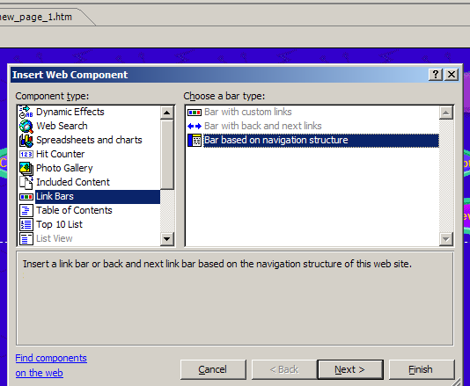

- Click “Next”, “Next”, choose the position you want the link bar (on the top of the page or on the left side), and click “Finish”.

