Opening Your Web Page without Internet Explorer

- Open Microsoft FrontPage: Click on Start, All Programs, Microsoft Office, and Microsoft Office FrontPage.

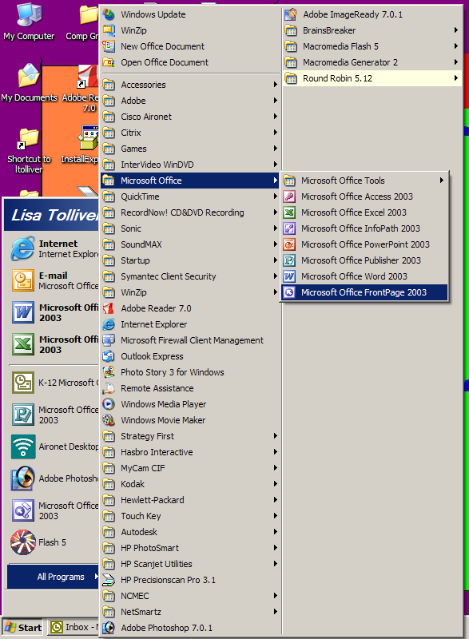
Start

All Programs

Microsoft Office
Microsoft Office FrontPage

- Click on “File”, “open site”. (You may need to go to the arrows at the bottom of the “file” menu to get more options so you can see “open site”.)
File

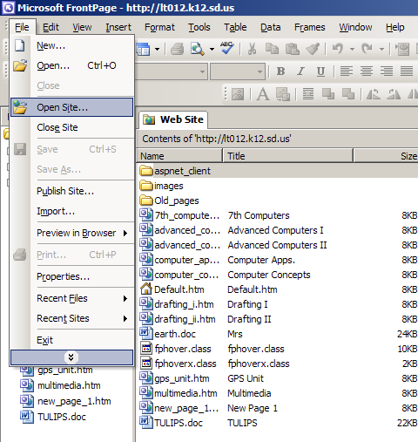
Arrows for more options

Open Site

- Log in using your state username and password.

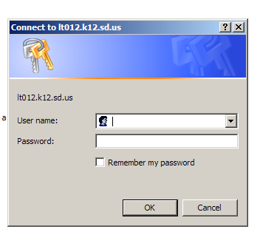

- Click “OK”.
- Your web site will open in “Folders” view. Double click on the default.htm page to open your homepage and start working. You can also double-click any other page (with .htm) you wish to open up and work on.

